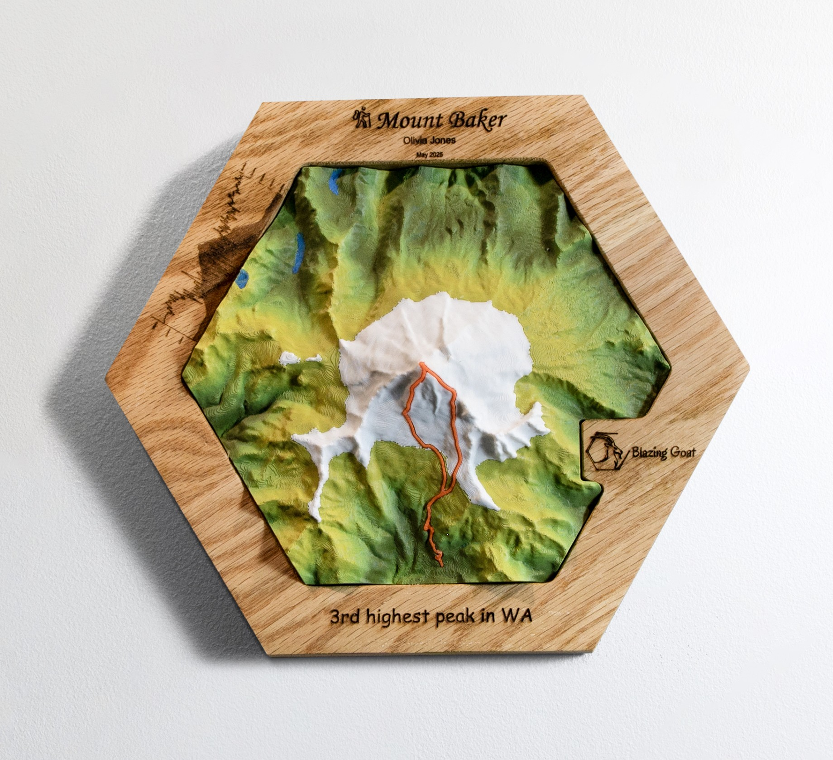


Meet the Artist: Harry.
I am a Seattle-based artist, mountaineer, and endurance athlete on a mission to make your outdoor milestones tangible. Each piece is made with your GPS tracks, so you have exact memories of your adventure.
Every great effort leaves a mark, whether it’s grinding through a grueling city marathon, hitting a rhythmic urban bike ride, or standing on a windswept summit. Topo Sculptures transform those raw GPS coordinates or strava/alltrails trackings into premium, three-dimensional physical artifacts.
Using digital artistry and high-end craftsmanship, this collection captures the exact lines of local running routes, cycling loops, and iconic Northwest peaks. Because our adventures are always evolving, these pieces are entirely modular, and can be rearranged using magnets, allowing you to arrange, connect, and build a physical timeline of your athletic achievements.
Every run, ride, and climb demands grit. These sculptures turn the lines on your fitness tracker into a lasting, tangible reminder of what you are capable of achieving.

Follow me on Instagram! @blazinggoat Visit my website! www.blazinggoat.com



